PROJECT REPORT

By:

Mounika polisetti

Sri Lakshmi Sowjanya Alla

**GROUP NAME: KABALI 2.0**

**Course: Capacity Analysis**

AIM:

The goal of the project is to find the average time that a customer spends in a petrol bunk to get the service done.

METHOD:

We have considered a petrol bunk by using M/M/1 queuing system where the arrivals follow a Poisson process and service times are exponentially distributed. Queue capacity of the system is infinite with first come first serve mode. We wanted to observe how time differs with respect to a customer spent in the petrol bunk when there is a single server system and three server system.

EXPERIMENT:

* Here the arrivals follow a Poisson process and service times are exponentially distributed.
* We have simulated M/M/1 by giving the lambda, mu and simulation time values.
* We wanted to check the average time of a customer spending in a system when there are three M/M/1 servers and comparing with M/M/1 to M/M/3.
* Therefore, we first calculated the average time that customer spends in a single server system.
* We then calculated the average time of the customer spending in three server systems by simulating three M/M/1 systems by using arrival and service rate common to all the servers.
* We then calculated the total mean of individual average times of three M/M/1 servers.
* As we have calculated the average time of customer in a single and three server systems , we subtracted the average time in a single server from the total average time in a three server system so that we can analyze at what state M/M/3 system is better than M/M/1.

RESULT:

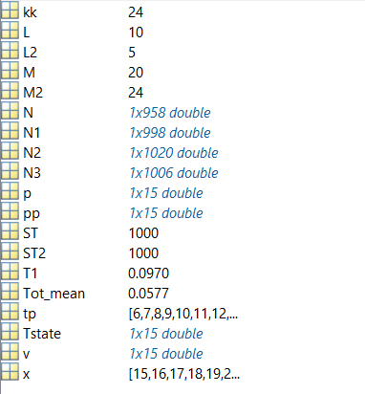

T1=average time spent by a customer in M/M/1 system.

Tot_mean=average time spent by overall customers in M/M/2 system.

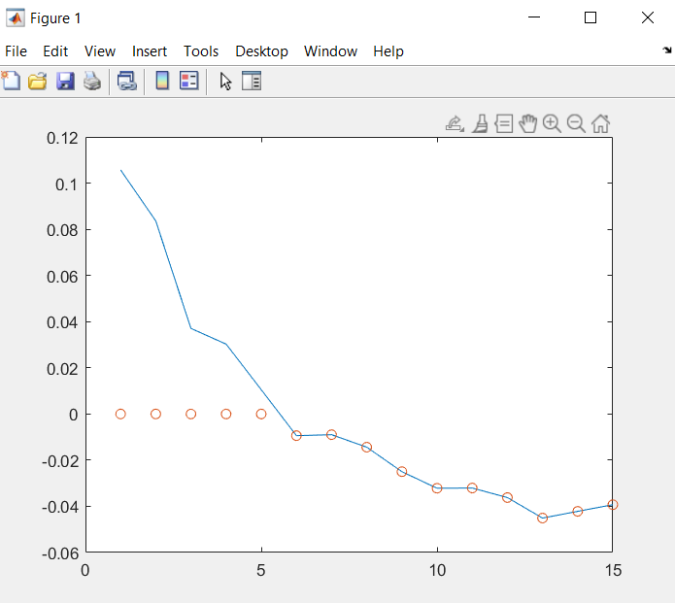

Here,

x axis resembles the state of the system

y axis resembles the difference of the Tot_mean and T1

This graph represents at what state M/M/3 system can give better service than M/M/1.

CONCLUSION:

After analyzing all the results we can conclude that if T1(average time spent by a customer in M/M/1 system) value is more compared to the Tot_mean(average time spent by overall customers in M/M/2 system) then M/M/3 will be more efficient than M/M/1.

APPENDIX:

L=10;M=20;ST=1000; %%(Lamda, mu, Simulation time)

L2=5;M2=10;ST2=1000; %%(Lamda2,Mu2, Simulation Time2)

Tstate=[]; %%(for storing the state value of the out put. we are creating an empty matrix)

%%%%%%%%%%%%%%%%%%%%%%%%%%%%%%%%%%%%

for kk=10:24 %%(states)

N=Q2MM1(L,M,ST); %Simulating the M/M/1

T1=mean(N)/L; %average time that a customer spends in the petrol bunk when there is single server system

%%%%%%%%%%%%%%%%%%%%%%%%%%%%%%%%%%

%simulating 2 parallel M/M/1 systems simultaneously with the same

%arrival rate, service rate and simulation time

L2=5;M2=kk;ST2=1000;

N1=Q2MM1(L2,M2,ST2);

N2=Q2MM1(L2,M2,ST2);

Tot_mean=mean([mean(N1)/L2,mean(N2)/L2]); %% by calculating the individual average times of 2 M/M/1 and taking the average is the total mean

Tstate=[Tstate,Tot_mean-T1];%% gives at what state the M/M/2 system is better to use that M/M/1

end

%%%%%%%

figure,plot(Tstate),hold on %% plots the graph of the current state and the difference value

p=Tstate; %time state

tp=find(p>0);

p(tp)=0;

plot(p,'o')%%%

%%%%%%%%%%%

tp=find(Tstate<=0);

v=10:24;

x=v(tp);

disp(x)

%v(tp) ressembles at what state the 2-server system is better than the 1 server system